**Cost Codes**

This should be changed to (Define Groups)

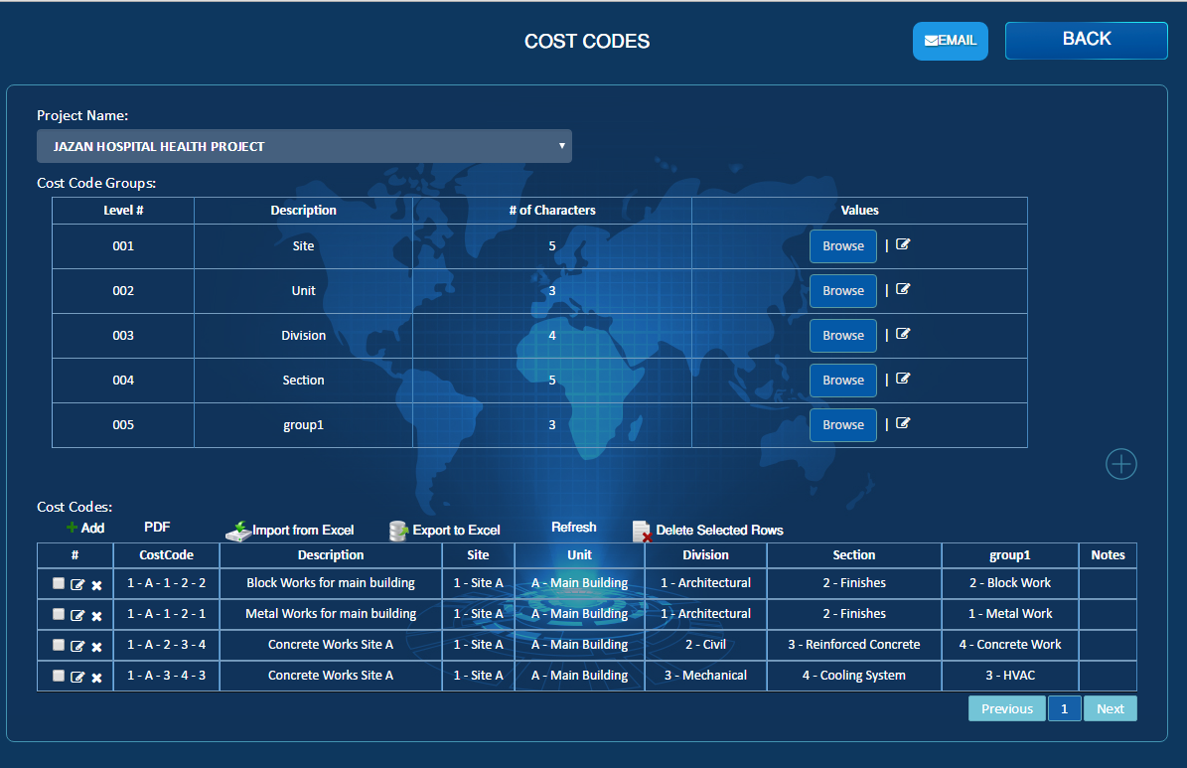

1. Delete option should be there for the cost code Groups, and pop up message to indicate that these group contains submenus will be deleted.
2. If this line items are used in the cost codes then it can’t be deleted.